GhostNet
Security Testing Report
Postman Test Results

Tester | Ummama Khan
Backend version | V2
Base URL | http://127.0.0.1:5000/api
Total tests | 18
Overall result | 17 passed

Test summary
Complete this table after running all tests. Mark each result as Pass or Fail and add any brief notes.

ID | Test name | Category | Result
T-01 | Successful registration | Authentication | Pass
T-02 | Duplicate username blocked | Authentication | Pass
T-03 | Role escalation via registration blocked | Authentication | Pass
T-04 | Successful login returns valid JWT | Authentication | Pass
T-05 | Wrong password returns generic error | Authentication | Pass
T-06 | Expired token rejected | Authentication | Pass
T-07 | Visitor cannot send messages | RBAC & Roles | Pass
T-08 | Non-Admin cannot call /admin/promote | RBAC & Roles | Pass
T-09 | Admin can promote users to valid roles | RBAC & Roles | Pass
T-10 | No token returns 401 not 403 | RBAC & Roles | Pass
T-11 | Member can send message to a cell | Chat & TTL | Pass
T-12 | XSS content is escaped (output encoding) | Chat & TTL | Pass
T-13 | Expired messages filtered server-side | Chat & TTL | Pass
T-14 | TTL=0 messages persist indefinitely | Chat & TTL | Pass
T-15 | Login rate limit enforced (5/min) | Security | Pass
T-16 | Register endpoint has no rate limit (gap) | Security | Fail
T-17 | Tampered token rejected | Security | Pass
T-18 | Debug mode is off in production | Security | Pass

Detailed test results
T-01 | Successful registration |  |  |  |  | Auth
Method  POST |  | Endpoint  /api/register | Expected status  201 |  | Result  Pass
Test steps |  |  |  | Expected result
- Open Postman, send POST /api/register with body: {"username": " TestUser ", "password": "Test1234"}  - Open data/users.json — verify new entry exists  - Confirm role is 'Visitor' and password starts with 'pbkdf2:sha256' |  |  |  | 201 OK · role forced to Visitor · password stored as pbkdf2:sha256 hash · success message returned
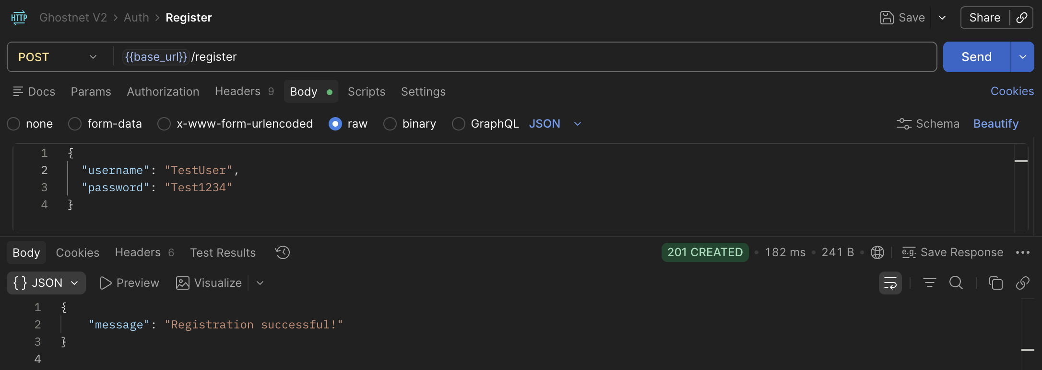
Observations / anomalies noted
Registration successful with username and password provided. Password is stored as hash and role is set to Visitor.

T-02 | Duplicate username blocked |  |  |  |  | Auth
Method  POST |  | Endpoint  /api/register | Expected status  400 |  | Result  Pass
Test steps |  |  |  | Expected result
- Register the same username 'TestUser' a second time  - Verify error message in response body |  |  |  | 400 Bad Request · error: 'User already exists' · no duplicate entry created
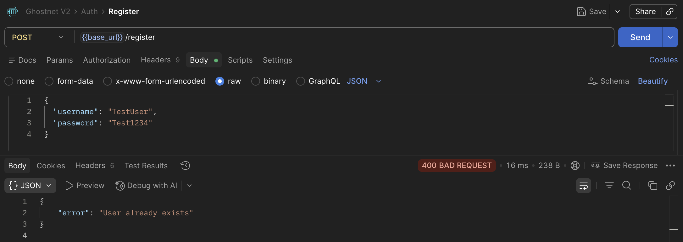
Observations / anomalies noted
Duplicate account registration rejected.

T-03 | Role escalation via registration blocked |  |  |  |  | Auth
Method  POST |  | Endpoint  /api/register | Expected status  201 |  | Result  Pass
Test steps |  |  |  | Expected result
- Send POST /api/register with body: {"username":"hacker","password":"Test1234","role":"Admin"}  - Check response status (should be 201)  - Open users.json — confirm role is 'Visitor' not 'Admin' |  |  |  | 201 · role field in JSON body is silently ignored · user created with role Visitor regardless
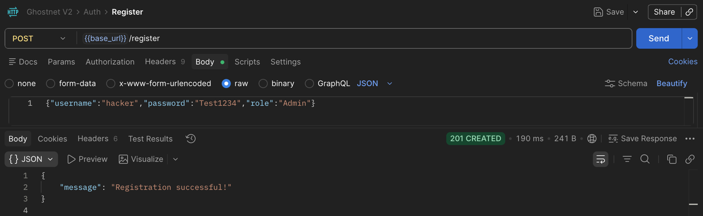
Observations / anomalies noted
Role automatically set to Visitor even if attempt to escalate role.

T-04 | Successful login |  |  |  |  | Auth
Method  POST |  | Endpoint  /api/login | Expected status  200 |  | Result  Pass
Test steps |  |  |  | Expected result
- Send POST /api/login with valid credentials  - Confirm response has 'token' and 'role' |  |  |  | 200 OK · response contains 'token' and 'role' fields · JWT payload has username, role
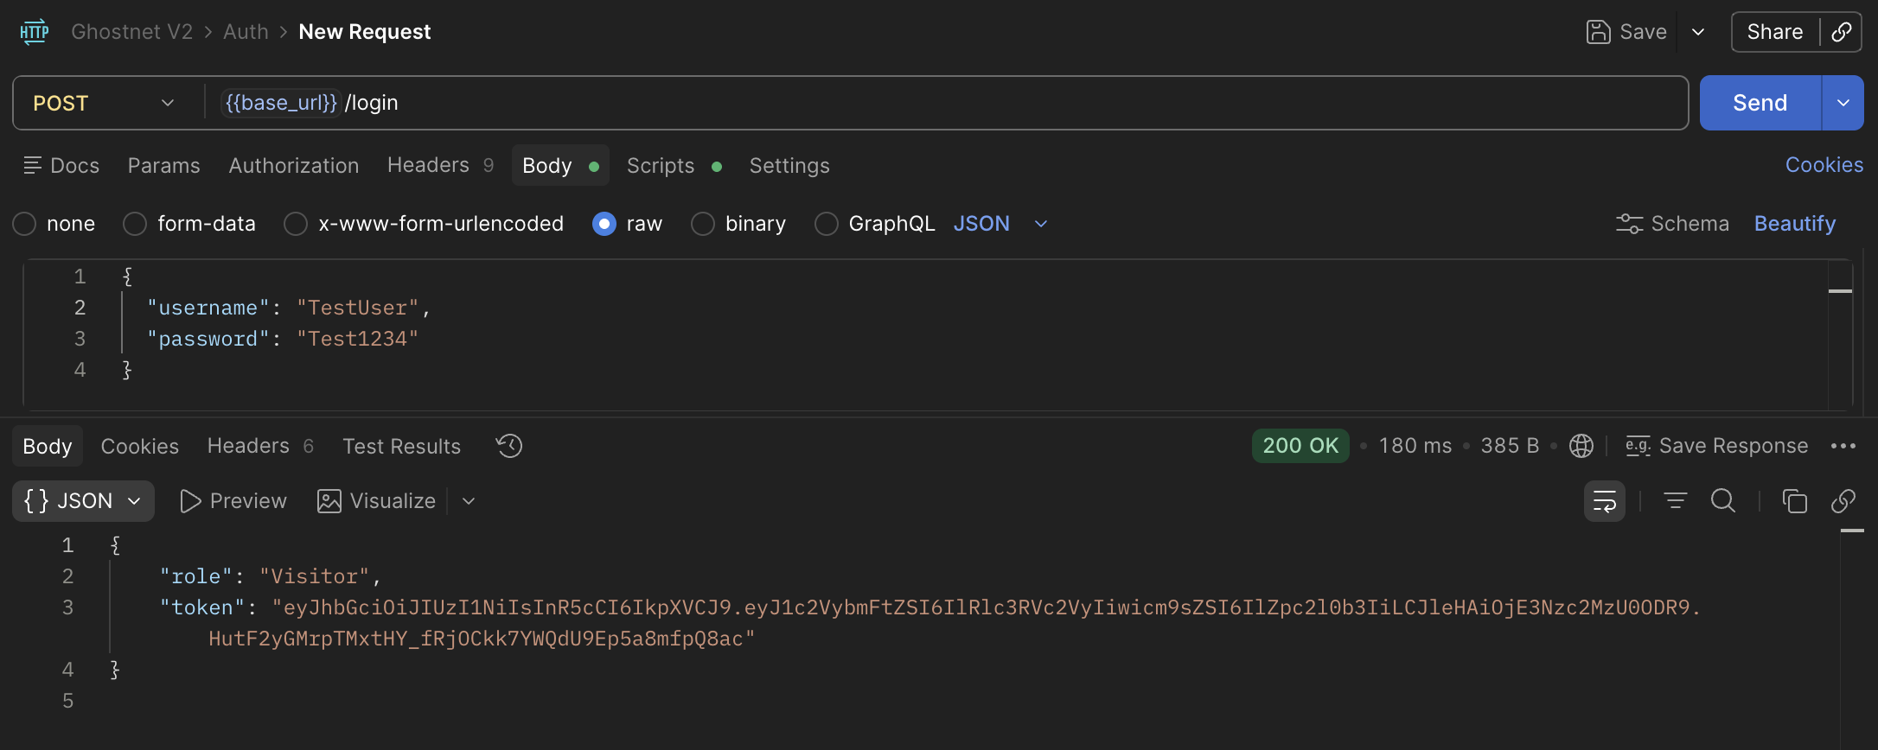
Observations / anomalies noted
Login successful with valid name and password.

T-05 | Wrong password returns generic error |  |  |  |  | Auth
Method  POST |  | Endpoint  /api/login | Expected status  401 |  | Result  Pass
Test steps |  |  |  | Expected result
- Login with correct username but wrong password — note the error message  - Login with a username that does not exist — note the error message  - Confirm both messages are identical: 'Invalid username or password' |  |  |  | 401 · same error message for wrong password AND non-existent user — no user enumeration
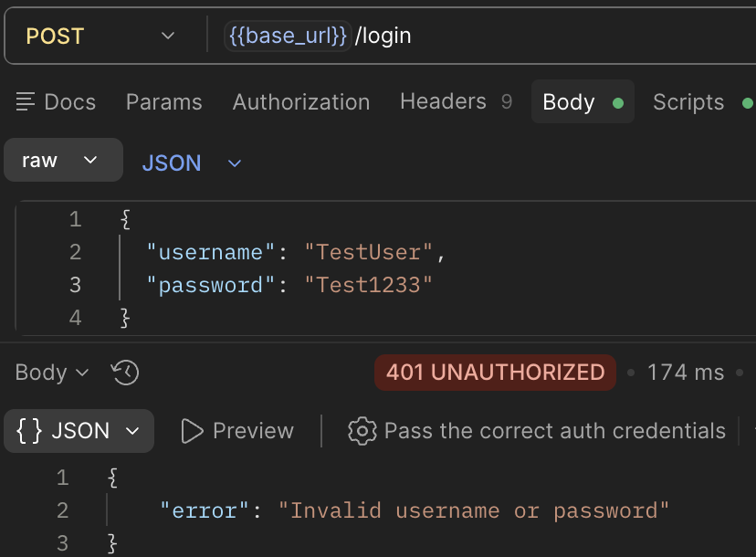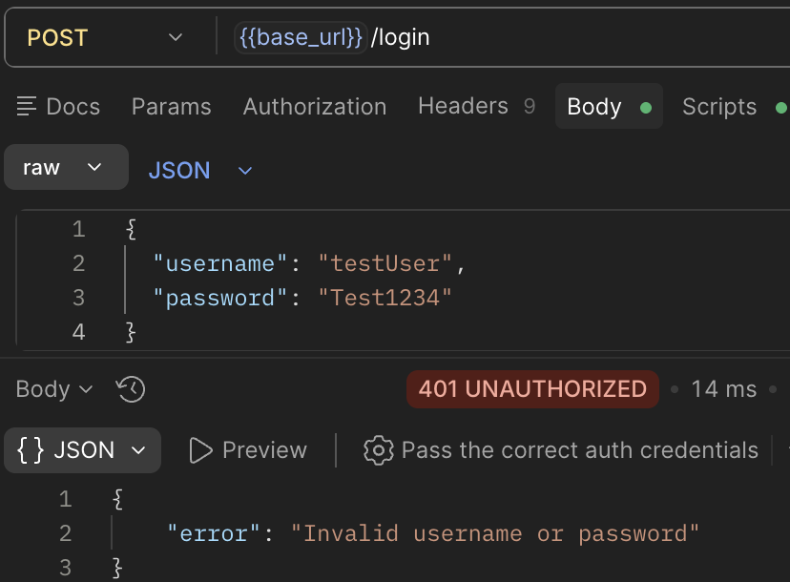
Observations / anomalies noted
Login rejected with invalid username or password and error message only displays generic message to not give a lot of information.

T-06 | Expired token rejected |  |  |  | Auth
Method  Security |  | Endpoint  Any protected endpoint | Expected status  401 | Result  Pass
Test steps |  |  | Expected result
- Send message after 1 hour of logging in  - Confirm 401 response |  |  | 401 · error: 'Token has expired!' · request blocked
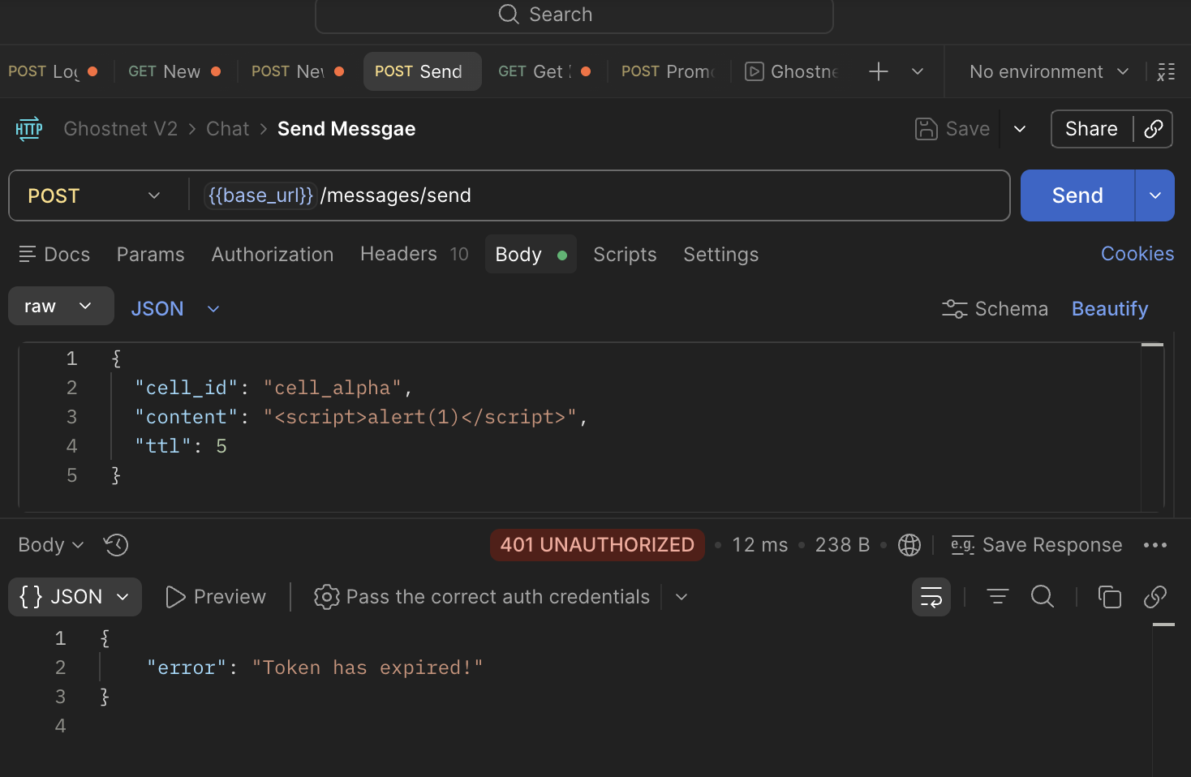
Observations / anomalies noted
Message not sent after 1 hour of login as token is expired.

T-07 | Visitor cannot send messages |  |  |  |  | RBAC
Method  POST |  | Endpoint  /api/messages/send | Expected status  403 |  | Result  Pass
Test steps |  |  |  | Expected result
- Register a new user (role defaults to Visitor)  - Login as that user and copy the token  - Send POST /api/messages/send with the Visitor token  - Confirm 403 response |  |  |  | 403 Forbidden · error: 'Unauthorized: Insufficient privileges'
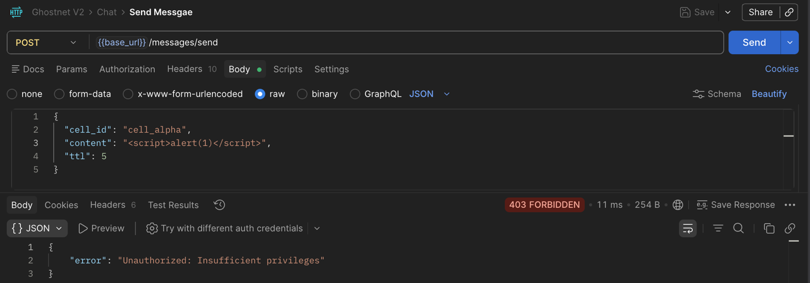
Observations / anomalies noted
Access to messages denied to Visitor.

T-08 | Non-Admin cannot call /admin/promote |  |  |  |  | RBAC
Method  POST |  | Endpoint  /api/admin/promote | Expected status  403 |  | Result  Pass
Test steps |  |  |  | Expected result
- Promote TestUser to Member using the Admin account (sofia_test)  - Login as TestUser (Member) and call POST /api/admin/promote  - Confirm 403  - Promote TestUser to Member, repeat test — confirm still 403 |  |  |  | 403 for both Member and Leader roles · only Admin may call this endpoint
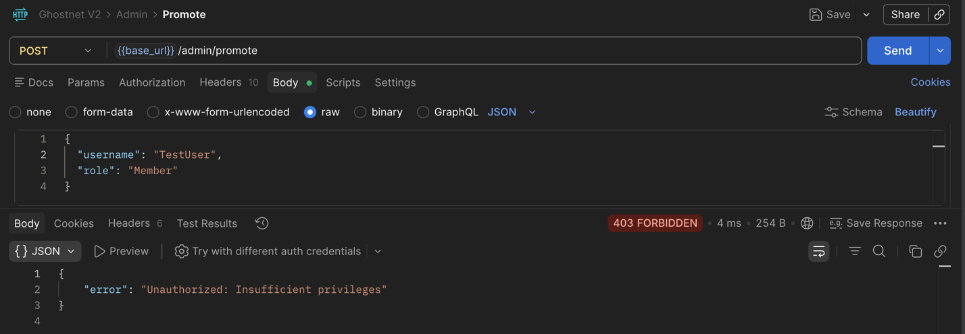
Observations / anomalies noted
Members can not promote others.

T-09 | Admin can promote users to valid roles |  |  |  |  |  | RBAC
Method  POST |  | Endpoint  /api/admin/promote | Expected status  200 / 400 |  | Result  Pass / Fail | Notes
Test steps |  |  |  | Expected result
- Login as sofia_test (Admin)  - POST /api/admin/promote with {"username":" TestUser ","role":"Member"}  - Confirm 200 and check users.json for updated role |  |  |  | 200 for valid roles (Visitor, Member, Leader, Admin) · 400 for invalid role like 'SuperAdmin'
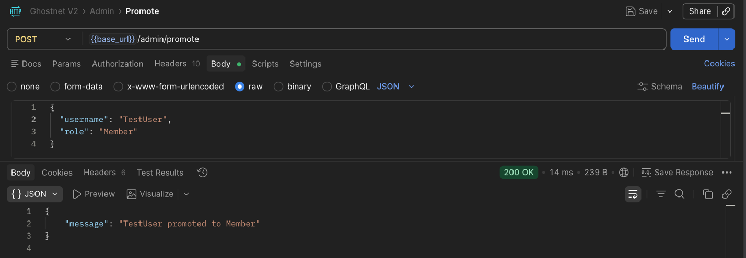
Observations / anomalies noted
Admin can promote Visitors to Member.

T-10 | No token returns 401 not 403 |  |  |  |  | RBAC
Method  Security |  | Endpoint  /api/messages/send | Expected status  401 |  | Result  Pass
Test steps |  |  |  | Expected result
- Send POST /api/messages/send with NO Authorization header  - Confirm return 401 with 'Token is missing!' |  |  |  | 401 · error: 'Token is missing!' (unauthenticated — correct distinction from 403 unauthorised)
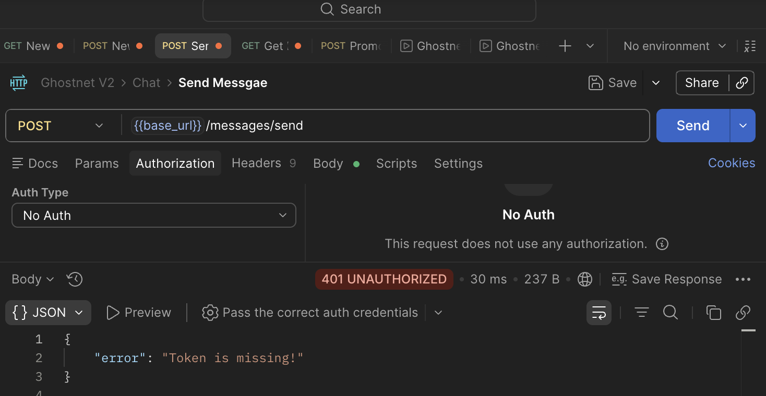
Observations / anomalies noted
Messages without tokens can not be sent.

T-11 | Member can send message to a cell |  |  |  |  |  | Chat
Method  POST |  | Endpoint  /api/messages/send | Expected status  200 |  | Result  Pass / Fail | Notes
Test steps |  |  |  | Expected result
- Login as a Member-role user  - POST /api/messages/send with {"cell_id":"cell_beta","content":"hello","ttl":5}  - Confirm 200 response  - GET /api/messages/cell_beta — confirm message appears |  |  |  | 200 · message stored with id, sender, timestamp, expiry fields · appears on GET
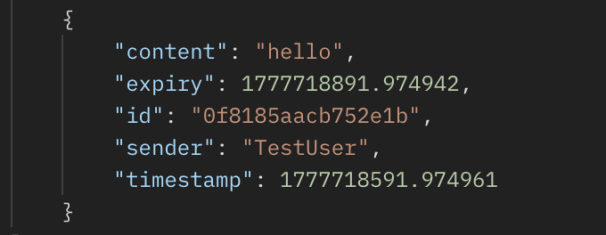
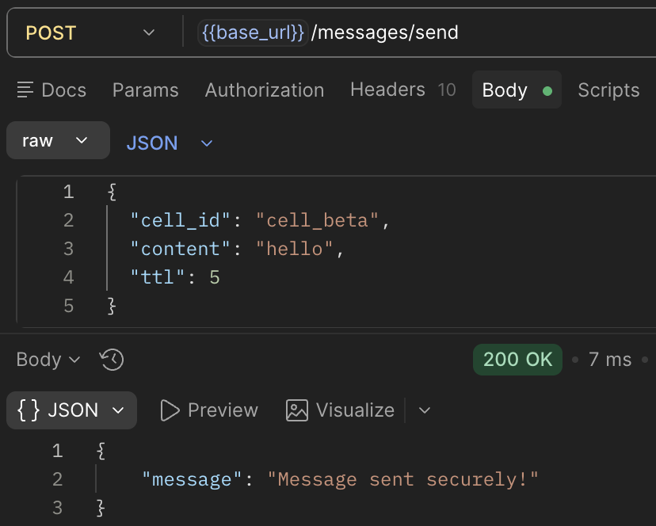
Observations / anomalies noted
Members can securely send messages.

T-12 | XSS content is escaped (output encoding) |  |  |  |  | Chat
Method  Security |  | Endpoint  /api/messages/send | Expected status  200 |  | Result  Pass
Test steps |  |  |  | Expected result
- Send a message with content: <script>alert(1)</script>  - GET messages — check 'content' field in the JSON response  - Confirm it shows &lt;script&gt;alert(1)&lt;/script&gt; (HTML-encoded)  - Load the frontend — confirm no alert box fires |  |  |  | Content stored as HTML entities · &lt;script&gt;alert(1)&lt;/script&gt; · no script execution in browser
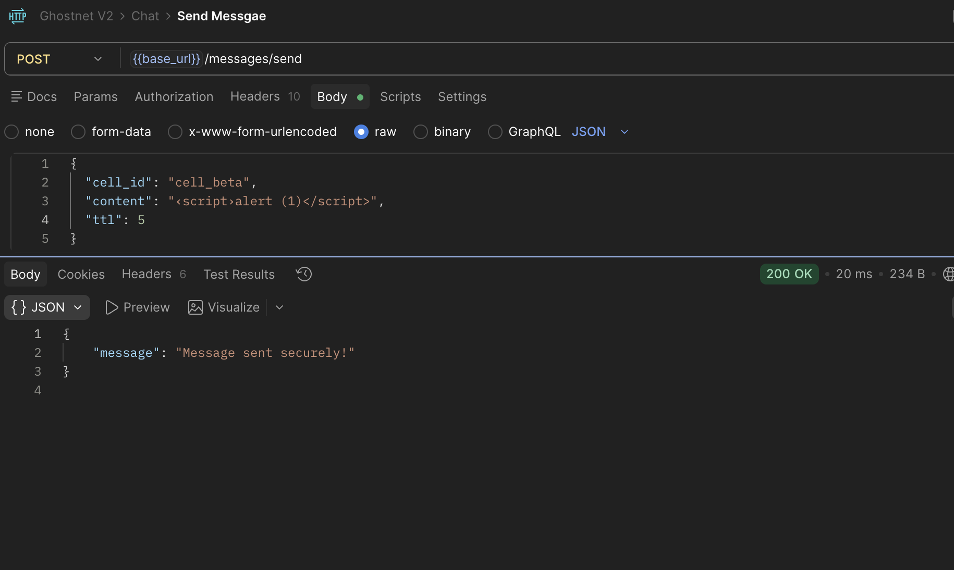
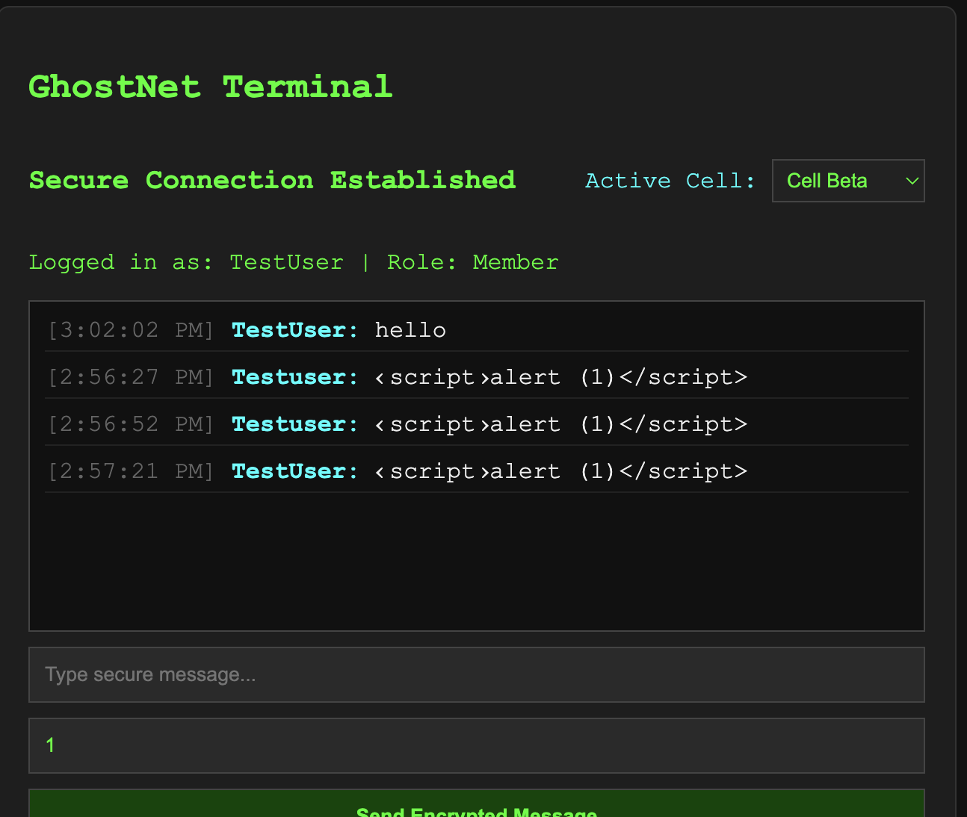
Observations / anomalies noted
XSS script is not executed.

T-13 | Expired messages filtered server-side |  |  |  |  | Chat
Method  GET |  | Endpoint  /api/messages/cell_alpha | Expected status  200 |  | Result  Pass
Test steps |  |  |  | Expected result
- Send a message with ttl: 1 (1 minute)  - Immediately GET messages — confirm message appears  - Wait 61 seconds, GET again  - Confirm message is absent from response (still in messages.json but filtered) |  |  |  | Message present immediately · absent from response after TTL expires · client cannot override server-side filtering

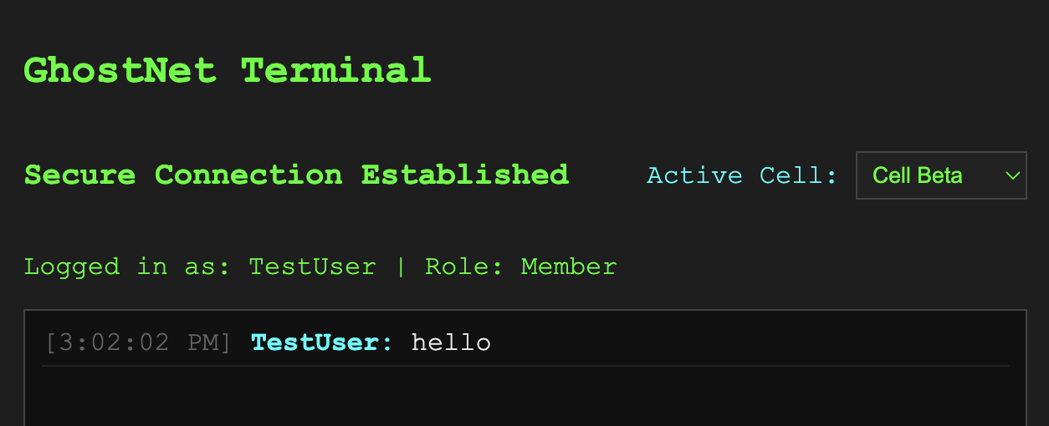
Observations / anomalies noted
Messages with Time to Live (TTL) not equal to 0 are wiped after the set time.

T-14 | TTL=0 messages persist indefinitely |  |  |  |  | Chat
Method  GET |  | Endpoint  /api/messages/cell_alpha | Expected status  200 |  | Result  Pass
Test steps |  |  |  | Expected result
- Send a message with ttl: 0  - GET messages immediately — confirm it appears  - GET again after a few minutes — confirm still present  - Verify expiry: 0 in messages.json |  |  |  | expiry = 0 in storage · message always returned regardless of time elapsed

Observations / anomalies noted
Messages with TTL set to 0 exist indefinitely.

T-15 | Login rate limit enforced (5/min) |  |  |  |  | Security
Method  Security |  | Endpoint  /api/login | Expected status  429 |  | Result  Pass
Test steps |  |  |  | Expected result
- Use Postman Runner: select Login request, set iterations to 7, delay 500ms  - Run the collection  - Confirm requests 1–5 return 200, requests 6–7 return 429  - Wait 60 seconds and login again — confirm 200 (reset) |  |  |  | Requests 1-5: 200 OK · Request 6+: 429 Too Many Requests · limit resets after 60 seconds
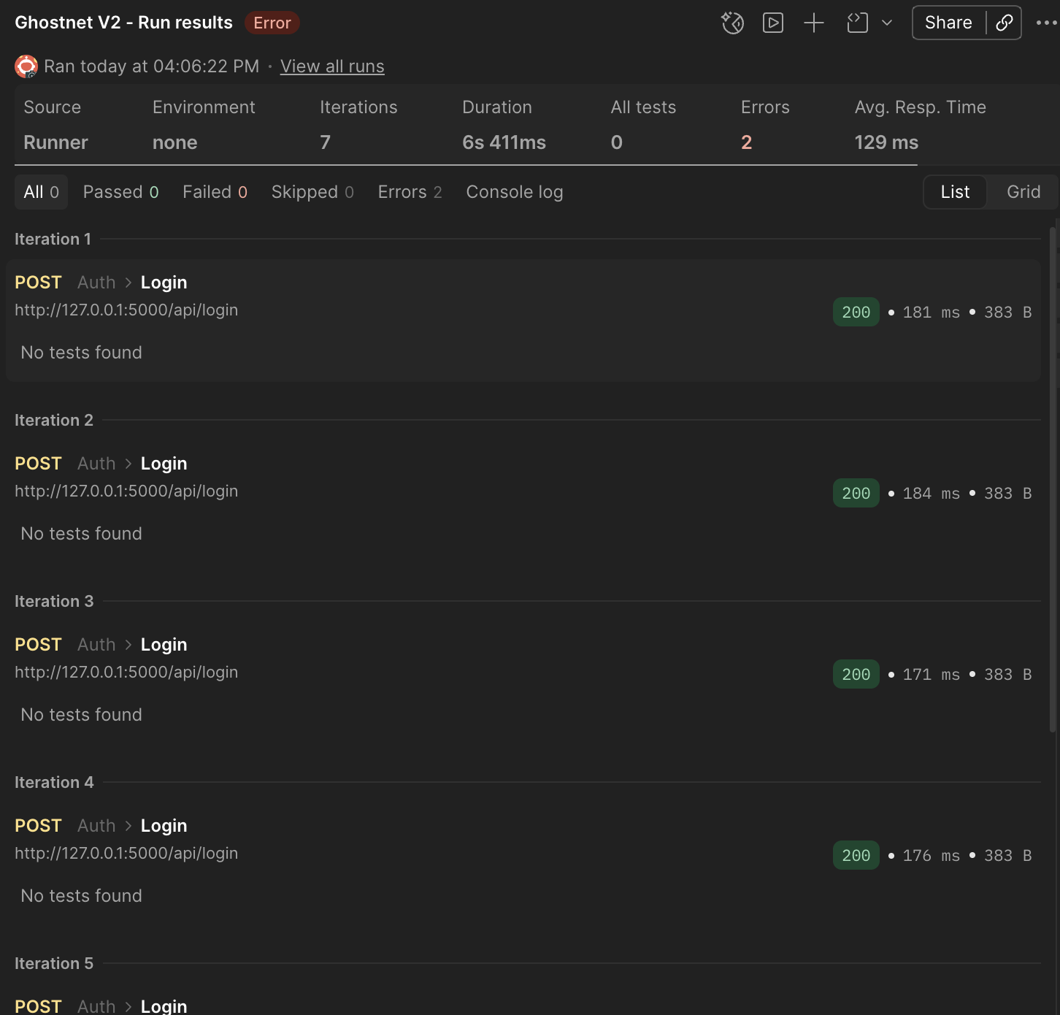
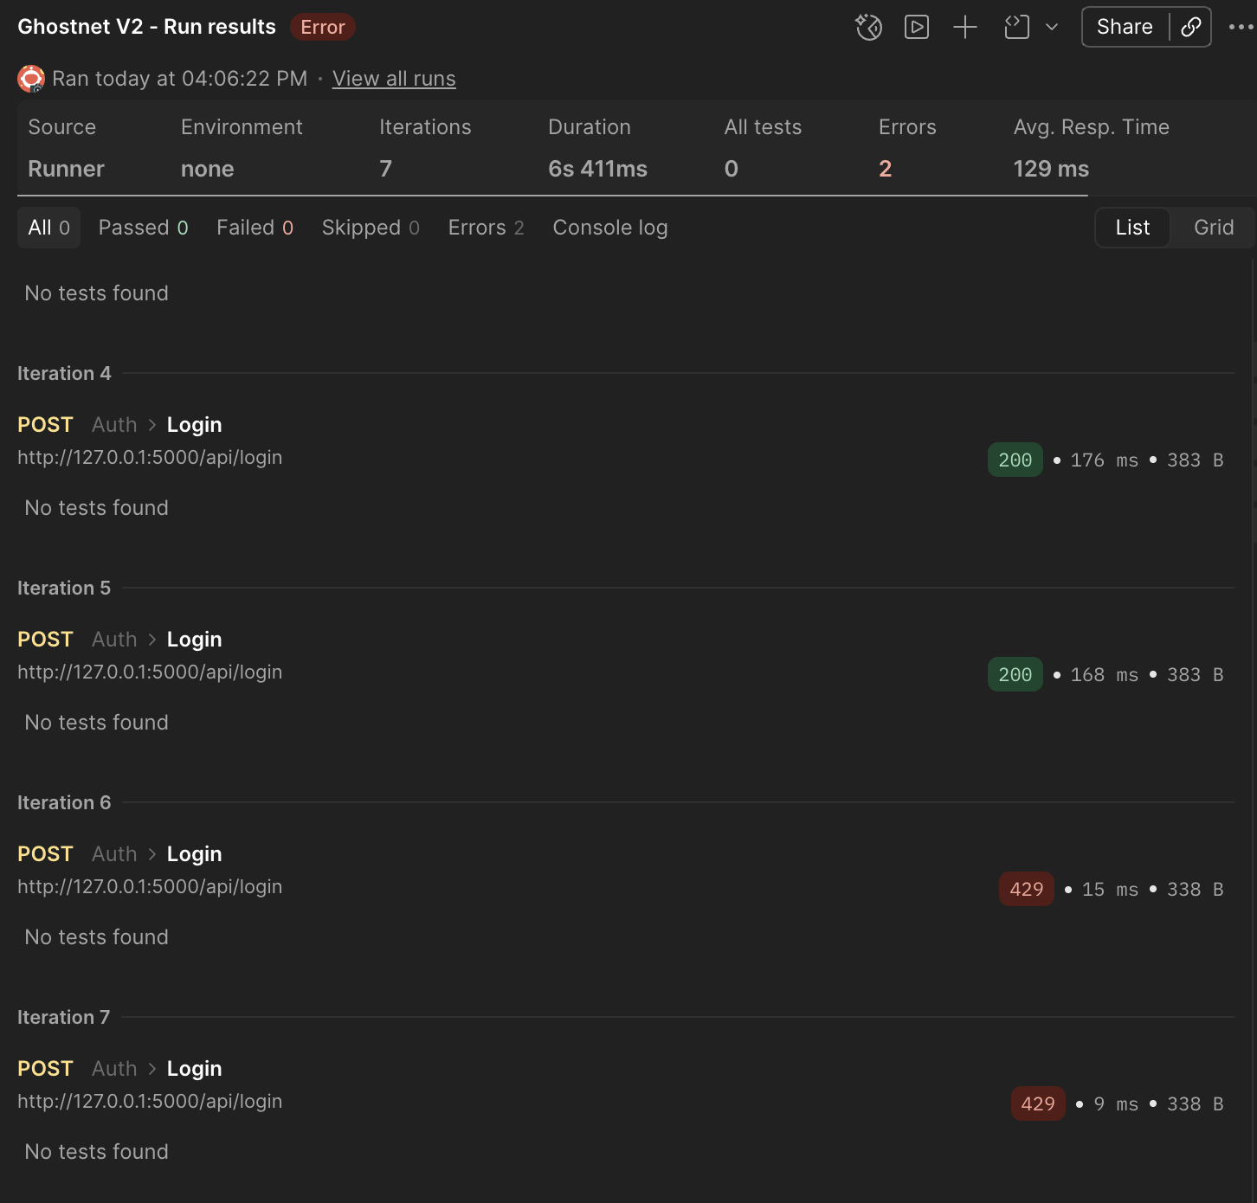
Observations / anomalies noted
Login rate limit is set to 5 per minute. Any more attempts are rejected.

T-16 | Register endpoint rate limit |  |  |  |  | Security
Method  Security |  | Endpoint  /api/register | Expected status  429 |  | Result  Fail
Test steps |  |  |  | Expected result
- Send 10+ POST /api/register requests rapidly with unique usernames  - Observe: no 429 is returned  - Document this as a missing security control |  |  |  | No 429 returned (known gap) · register is missing rate limiting · document as finding
Observations / anomalies noted
No rate limit on registration requests.

T-17 | Tampered token rejected |  |  |  |  |  | Security
Method  Security |  | Endpoint  /api/admin/promote | Expected status  401 |  | Result  Pass / Fail | Notes
Test steps |  |  |  | Expected result
- Login as a non-Admin user, copy the JWT  - Go to jwt.io, change payload role to 'Admin' without updating the signature  - Use the tampered token to call POST /api/admin/promote  - Confirm 401 'Token is invalid!' |  |  |  | 401 · error: 'Token is invalid!' · signature verification catches the tampering
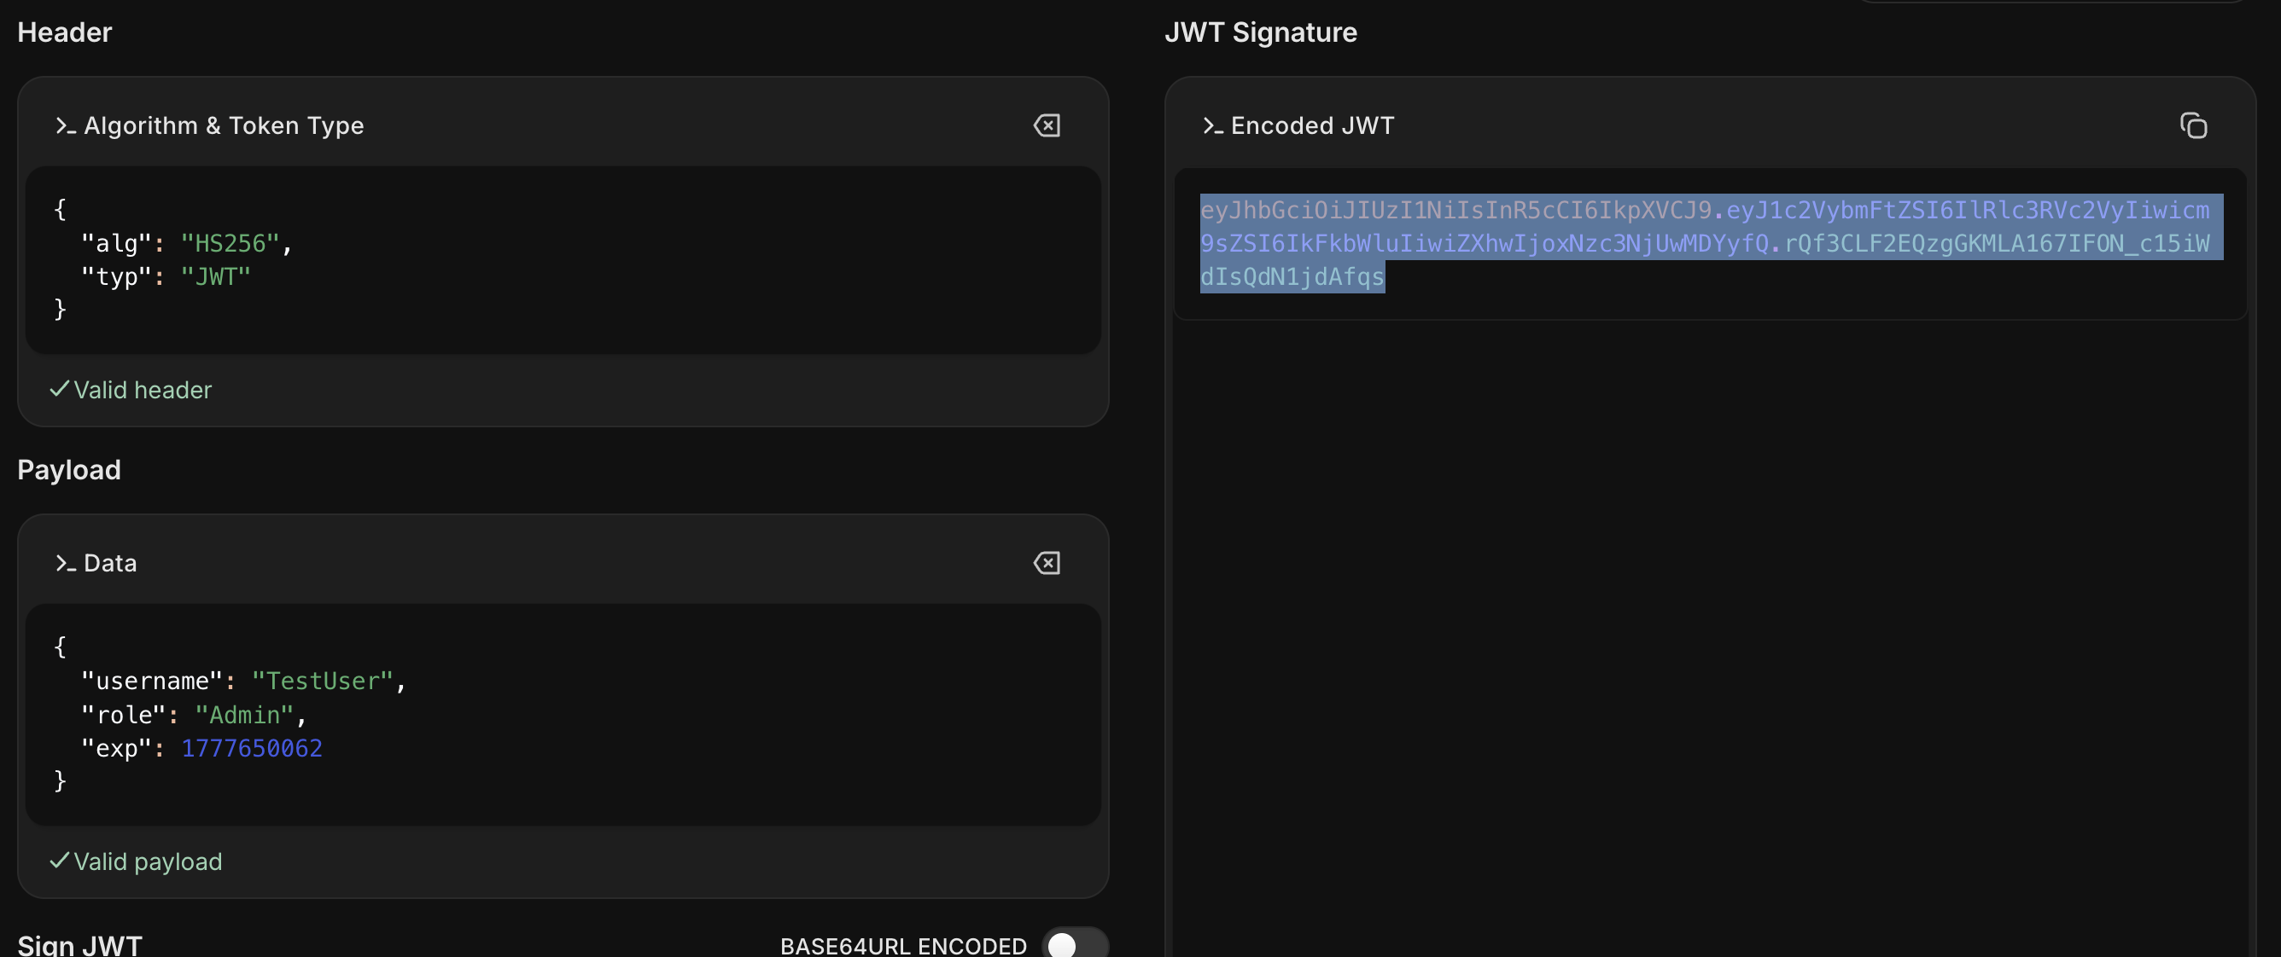
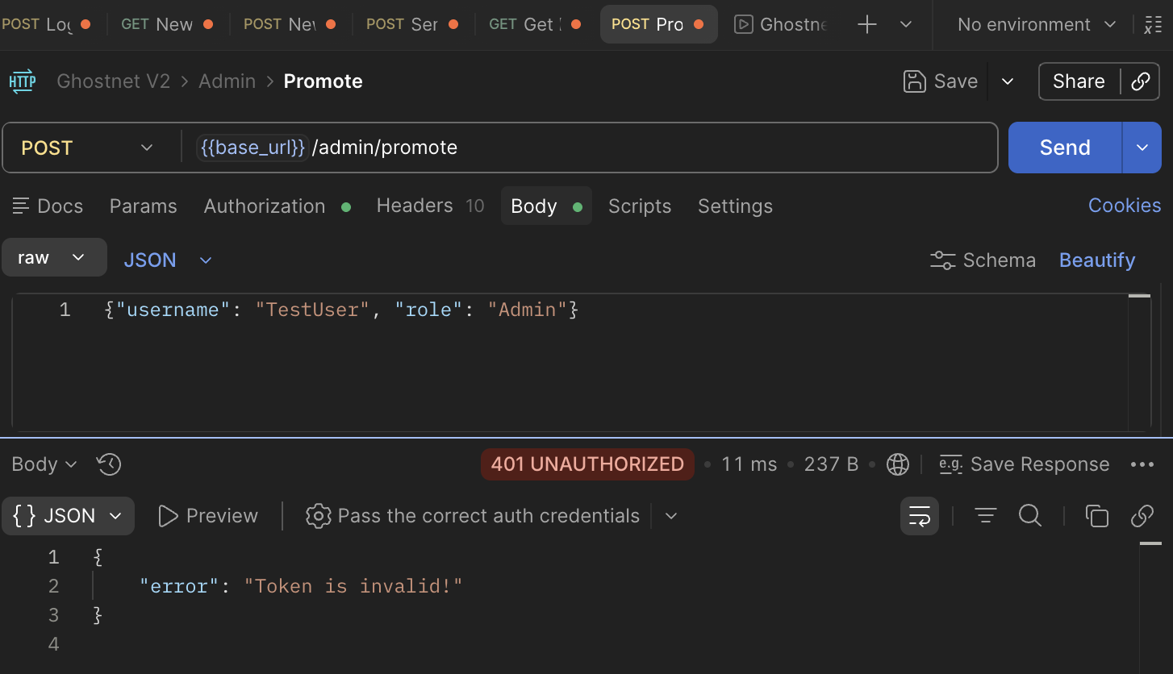
Observations / anomalies noted
A token has to be the same as the original to be valid and so accepted.

T-18 | Debug mode is off in production |  |  |  |  | Security
Method  Security |  | Endpoint  Any endpoint | Expected status  500 (generic) |  | Result  Pass
Test steps |  |  |  | Expected result
- Verify run.py has debug=False  - Trigger a server error (e.g. send malformed JSON body)  - Confirm response contains no traceback or internal file paths  - Screenshot the response to show only a generic error |  |  |  | No Python traceback or stack trace in response · generic error only · debug=False confirmed in run.py
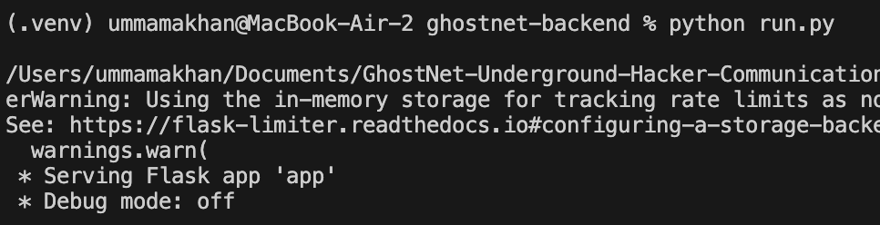
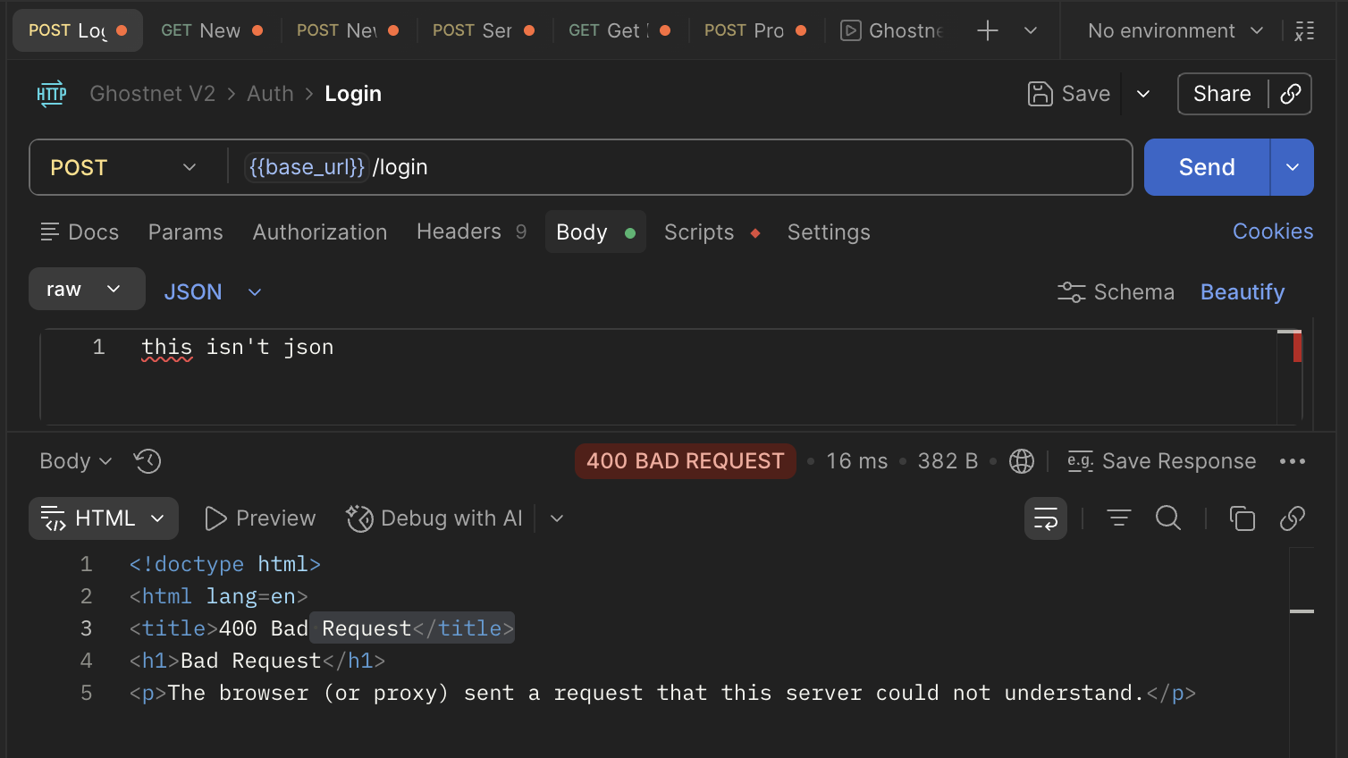
Observations / anomalies noted
No python traceback in the error.

Audit log verification
Check data/audit.log after each action. Paste a screenshot of the relevant log line in the column below.

Event | Expected log pattern | How to trigger | Pass / Fail
User registration | USER REGISTERED: TestUser with role Visitor | Register a new user | Pass
Successful login | LOGIN SUCCESS: TestUser | Login with valid credentials | Pass
Failed login | LOGIN FAILED: Attempt for username 'testuser' | Login with wrong password | Pass
Access denied | ACCESS DENIED: TestUser attempted restricted access | Call a forbidden endpoint | Pass
Role promotion | ROLE UPDATE: Admin 'sofia_test' promoted 'TestUser' to Member | Admin promotes a user | Pass
Message sent | MESSAGE SENT: TestUser posted to cell_alpha | Send a message as Member | Pass
Rate limit hit | ratelimit 5 per 1 minute exceeded at endpoint: auth.login | Exceed login rate limit | Pass

Final summary

Total tests  18 | Passed  17 | Failed  1 | Pass rate  94.5%

Security controls verified
Password hashing (PBKDF2)  Mass-assignment protection  JWT session tokens | RBAC deny-by-default  XSS output encoding  Server-side TTL enforcement | Login rate limiting (5/min)  Debug mode disabled  Audit logging

Identified gaps / recommendations
No rate limit on registration requests so bulk registration possible.

